Shift2Rail supports inclusive and gender balanced leadership for 21st century transport

September 27, 2019

Category: [Latest News](https://shift2rail.org/news/), [newsletter9](https://shift2rail.org/newsletter9/)

Shift2Rail took part in the conference ‘Towards a more inclusive and diverse transport sector’, organized by the European Commission’s DG MOVE held in Brussels on 26 September. Our Executive Director, Carlo Borghini, was invited by Commissioner Violeta Bulc to a high-level discussion on inclusive and gender balanced leadership for 21st century transport, together with 30 other CEOs from the transport sector. During the discussion, Mr Borghini took the opportunity to announce that Shift2Rail is looking forward to launching the second edition of the Shift2Rail Woman in Rail R&I Awards and to presenting the winners at InnoTrans 2020. During the event Violeta Bulc, Commissioner for Transport, launched a network of EU Diversity Ambassadors for the transport sector.

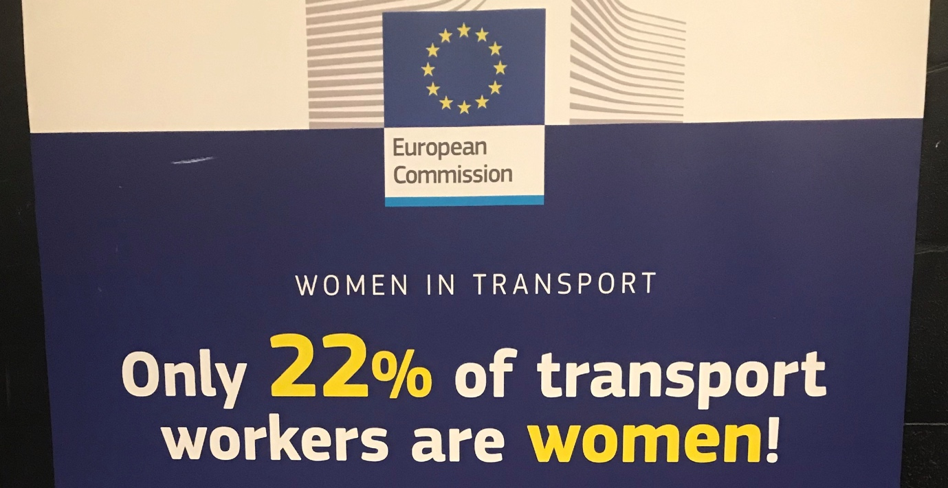

**What is the role of diversity ambassadors?**

The main task of ambassadors will be to promote the importance of having diverse workforces for the transport sector. They will disseminate information about measures that can be taken (see for instance the examples listed on the Transport-EU Platform for Change). They will also be encouraged to take various other initiatives at their level, bearing in mind the need to keep things flexible to accommodate each ambassador’s circumstances.

**Who can be a diversity ambassador?**

Anyone committed to the idea of achieving more diversity in the transport sector! The European Commission are looking for ambassadors from all genders and representing all transport sectors. Ambassadors’ profiles should range from students, to female and male transport workers, as well as from technicians to managers. Civil servants, politicians, civil society associations, academics are also welcome to join the network. There is no selection process as such as the emphasis is on individual commitment. Ideally however, ambassadors should have a sufficient command of the English language to ease communication between ambassadors. Are you interested? Please write to communication@s2r.europa.eu and we will put you in touch with the relevant colleagues at the European Commission.

**Have you signed the declaration on equal opportunities for women and men in the transport sector? Not yet? Click below to do it now! There is no time to lose; diversity and inclusiveness are essential for the ethical behaviour of an entity and a key to success! Shift2Rail is committed to this!**